Business Plan Regarding Social Media Marketing

Social media should be treated as a brand building tool, as well as an information tool for potential buyers. Decision makers are leaning heavily on social media to assist with company purchasing. 52% of B2B Marketers say Facebook is the most effective social marketing tool, 21% say LinkedIn is most important, 13% say Twitter, 4% say Google+, 4% say YouTube, 3% say Pinterest, and 2% say Instagram is most effective.

50% of all US citizens live in the Eastern Time Zone, and 80% live in the Eastern and Central Time Zone so posts should be posted according to the Eastern Time Zone clock when most users would be active.

The benefits to social media marketing include in descending order of importance, increased exposure, increased traffic, developed loyal fans, provided marketplace insight, generated leads, improved search rankings, grown business partners, established thought leadership, improved sales, and reduced marketing expenses.

I have laid out the plan by taking several major social media platforms and breaking them down individually into background information, the audience using that platform, the pros and cons, statistics, the strategy regarding that social platform, how analytics for that platform are tracked, and what the return is by using that platform.

1 Facebook

1.1 Background
1.1.1. Facebook is the world’s largest social network and allows users to share content, conversations, create events, and develop targeted ads.
1.1.2 Facebook is a unique platform in that it can be used both informally and professionally in regards to business promotion. Businesses can take both approaches on this application.
1.1.3 Used for creating media presence, but not as a primary source for communication. Facebook is mostly used by users for obtaining information.
    - Facebook’s best use for businesses is generating and fostering relationships with potential clients, as well as advertising.
- When making posts, provide business insight linking to industry news or ask users for feedback when posting pictures. Share stories of how Volute overcame challenges to connect with users on a personal level, which makes them more likely to become clients.
- You should not directly advertise on the Volute Facebook page because that turns fans off.
- Don’t get caught up in addressing customers in lengthy conversations. One comment on a post can boost the company reputation but note that everyone can see what is posted.
    - Facebook is ranked #2 behind YouTube for where users go to watch videos.
- Videos and pictures are more likely to encourage likes and shares by users while text posts are more likely to start conversation.
1.1.5 Facebook is the most compatible network with 3rd party applications and software.

  - Audience
1.2.1 Facebook, being the largest social network, creates a huge demographic which can and lead to both direct and indirect connections.
1.2.1.1 Businesses and Universities will see information posted and can then be directed to the Volute website for sales for more information
1.2.1.2 Students and professionals may see the information posted and share it which could lead to indirect marketing.
1.2.1.3 Facebook has “Audience Insights” which allows Volute to learn about their customer’s geography, demographics, lifestyle, and purchase behavior. These insights can help to better direct marketing messages that drive results.

  - Pros and Cons
    - Pros
- Facebook is the most mainstream platform with the highest percentage of users.
- Having a Facebook account establishes a name presence and following.
- It has the highest percentage of weekly “engaged” (Actively communicating) users.
- It is easy to drive traffic to another site with hyperlink capability and easy sharing.
- Facebook has the ability to advertise, view analytics, and target specific groups.
- Facebook users have easy access both on mobile and desktop to increase the probability of viewing content
    - Cons
- Facebook has the slowest growth rate of any major social media site.
- It’s less personal and less engaging with users on an individual level when compared to other social networks like Twitter and Instagram.
- An advertising budget is strongly recommended to promote the Facebook page and drive users there.
- Facebook is more time consuming to manage than other social networks.

  - Statistics
 | # Active Users | % of Pop using | % growth rate in last year | % users engaged weekly | Post Frequency | Best Times | Post Lifetime
Facebook | 1.55 Bill  as of  Nov 2015 | 72% | 2% | 91% | 1-2 posts per day | 1-4pm | 90 mins

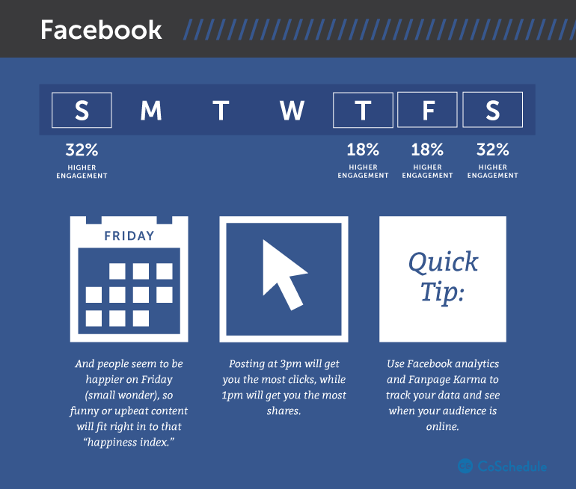

I. On Facebook, photos get 53% more likes, 104% more comments and 84% more click-throughs on links than text-based posts.
II. Shorter posts get 23% more interaction.
III. Using emoticons increase comments and shares by 33%, and likes by 57%.
IV. Engagement levels are higher on Thursday-Sunday.
V. Questions get more comments, likes and shares than non-questions.
VI. 35% of Facebook users like a page so they can participate in contests or to receive coupon discounts.

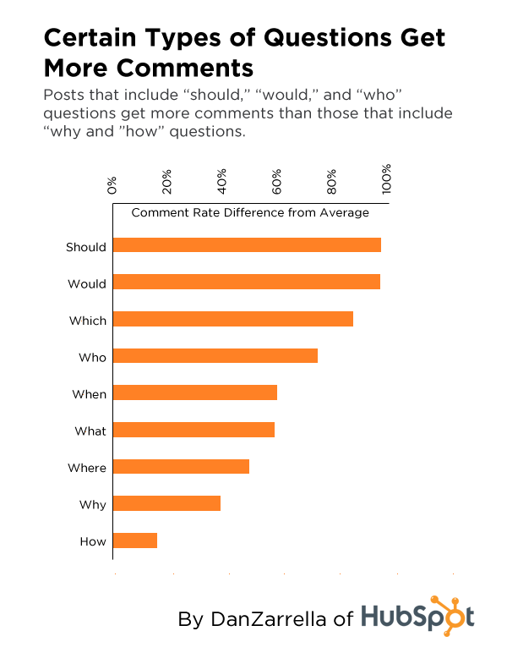

  - Social Media Plan regarding Facebook
- Check for interactions (comments, messages, likes). Strategically choose important ones to like or respond toward.
- Check analytics through Facebook or Hootsuite to verify the strategy plan is correct and working effectively.
- Research articles, and develop Facebook posts to be input into Hootsuite.
- Initially one post will be posted each day through the work week but if more content is created, up to two posts may be done during the work week.
- Text posts at 3pm.
- Image or videos posted at 1pm.
- Research users, find out their interests, when they are active, how to appeal to them track hashtags, and track competitors.
- Potentially create Facebook promotions drive traffic to the Volute Facebook page.

  - Analytics
    - Facebook has one of the most extensive social tracking analytics of any social network.
      - Tracking of users can be based on demographics, lifestyle, and purchase behavior.
- This can be used to better connect with users and provide them with more relevant posts.
- Information that can be obtained from google analytics include the number of views, audience impressions, click throughs, likes, shares, engagement levels, demographics, follows, etc.
1.6.2 Facebook is very compatible for tracking analytics using 3rd party applications such as Hootsuite and others.

1.7 What is the return?
1.7.1 Develop a social presence on the most Mainstream, most searched social network.
1.7.2 Many users search companies on Facebook rather than searching for their actual website through a search engine.
1.7.3 Using Facebook will provide users with information about the company, upcoming events, who Volute is communicating with, and social happenings.
1.7.4 Facebook serves as cost effective advertising and self promotion of the Volute product.
1.7.5 Facebook can be used to create a network of devoted followers who will potentially like and share Volute postings to stimulate chatter and drive business sales.
1.7.6 Facebook allows Volute to better connect with users, finding out what features, apps and selling points are most important to them as consumers.

- Twitter

2.1 Background
2.1.1 Twitter is a popular social network with roughly 1/4 the user base of Facebook.
2.1.2 Twitter is less formal than Facebook and more personal.
2.1.3 Hashtags allow connectivity to particular topics which in turn create a greater potential for traffic to view the content.
2.1.4 Twitter has text limitations which means language must be clean and concise.
2.1.5 Twitter’s best use for businesses is promoting events, news and specials, and also fostering conversations that show off Volute’s experience.
2.1.5.1 When making posts, asking a question or providing an image stimulates more chatter than posting a text statement.
2.1.5.2 Retweeting or sharing a link to a related article with a posed question would make for an ideal tweet.
2.1.6 Twitter is better than Facebook for connecting with users at an individual level.
2.1.6.1 There is a more personalized and user friendly messaging system than other social media networks.
2.1.6.2 All posts fall into a public newsfeed which allows for anyone to potentially view them.
2.1.7 Twitter is less visual than Facebook.
2.1.7.1 Most posts on Twitter are in the form of text, however like Facebook, images are more likely to stimulate engagement.
2.1.7.2 Images are not as easily viewable because depending on the source type, they may only show up as a .url unless clicked on.

  - Audience
2.2.1 Twitter has a large demographic which leads to both direct and indirect marketing.
2.2.2 Twitter has a higher percentage of businesses using it, and also business owners, fan pages, corporations and celebrities (who have large followings). Each of them posting content at a higher level than other social networking sites.
2.2.2.1 Posting a well thought tweet directed toward a user with a large following can stimulate chatter.
I. Fans of that user may comment, favorite, or retweet which promotes the Volute Twitter page and driving traffic there.
II. Popular users may share, favorite, or retweet Volute’s post as well, which would help to gain chatter, followers, and interactions.

  - Pros and Cons
    - Pros
- Easily connect with users quickly and personally.
- There is a massive user audience on Twitter so it’s easy to find a user group to appeal toward.
- Every tweet will go to your followers, and if hashtags are used, tweet viewer audiences may extend even further.
- Twitter allows the user to search Twitter to find related content.
- Tweets are short, concise and quick to make.
- Even though Twitter only has 1/4 the user base of Facebook, there is nearly the same amount of user activity.
- Users are less bothered by frequent posting than they are on other social media networks.
2.3.2 Cons:
- Twitter is mostly used by people during breaks, commutes, and downtime so businesses trying to appeal to them is more challenging without getting innovative.
- With so many users having the ability to view all tweets, tweets can become easily buried within newsfeeds.
- Twitter is mostly text based, making it harder to engage the audience.
- The 140-character limit on Tweets makes it potentially challenging to get the point across.
- It’s not easy to advertise for small businesses because users don’t listen to other users unless they see there is a large following.
- Users are less likely to follow a user with only a few posts and a small following.
- Twitter requires a lot of time to find relevant articles and post thoughtful tweets related to them.

  - Statistics
 | # Active Users | % of Pop using | % growth rate in last year | % users engaged weekly | Post Frequency | Best Times | Post Lifetime
Twitter | 320 Mil as of  Sept 2015 | 23% | 7.5% | 59% | 1-3 posts per day | 7-9am  5-8pm | 18 mins
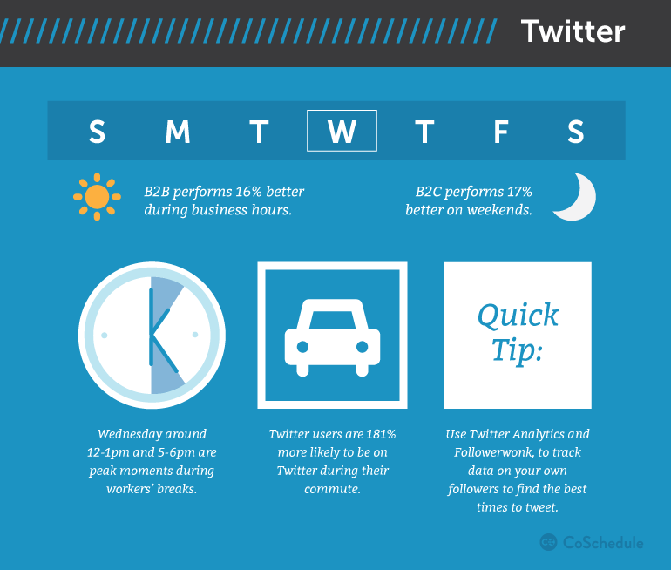

- Twitter engagement for brands is 17% higher on the weekends.
- Tweets with an image or link get two times the engagement rate.
- Tweets with less characters have a higher engagement.
- Twitter’s fastest growing demographic is 55-64 year olds.
- Tweets with Hashtags get more engagement.
- Twitter users primarily use twitter during commutes so tweeting between 7-9am and 5-8pm are ideal times.
- Tweets that include links are 86% more likely to be retweeted.
  - Social Media Plan regarding Twitter
- Check for interactions, (comments, direct messages, and favorites). Strategically choose which ones to respond toward.
- Check Twitter analytics either through Hootsuite or Twitter analytics.
- Research articles both on Twitter and other sources to choose articles in which post or comment.
- Research and develop posts to be input into Hootsuite.
- Posts should primarily consist of articles, updates, photographs, video links, or questions.
- Posts should occur 1-3 times a day through the work week and more posts should occur on the weekend and Wednesdays.
- Posts should be posted between 7-9am, 12-1pm, and/or 5-6pm.
- Interact with other users. answer questions they may have. Like or retweet their statuses. Give mentions to them in a status.
- Research users, find out their interests, when they are active, how to appeal to them, what engages them most, track hashtags, and track competitors.

  - Analytics
    - Twitter has its own analytics, viewable at https://analytics.twitter.com/
      - On Twitter analytics, the user is able to see their top tweets, user impressions, recommendations to gain interactions, Top followers, number of followers, followers gained or lost, impressions, and other statistics.
    - Twitter is also one of the most compatible social networks at connecting with 3rd party software and applications like Hootsuite to track analytics.

2.7 What is the return?
2.7.1 Develop a social media presence on the most news oriented social network.
2.7.2 Provide users with upcoming events, social happenings, business insight, and noteworthy articles.
2.7.3 Gain a following and increased awareness by communicating with other popular twitter accounts. If Volute and Columbia University are interacting, people are going to notice.
2.7.4 Show of Volute’s experience and knowledge by interacting and answering other user’s questions related to the field.
2.7.5 Use Twitter to create a network of devoted followers who will potentially retweet and like Volute’s postings to stimulate chatter and drive business sales.
2.7.6 Twitter is better at connecting with users, showing off Volute’s knowledge and experience, finding out what features and apps are selling points and also, which features are most important to them as consumers.

- YouTube

3.1 Background
3.1.1 YouTube is the 2nd most used social network.
3.1.2 YouTube is unique in the sense that it is primarily used as a platform for posting videos.
3.1.3. Like other social media networks, YouTube allows for individuals to post videos, send replies, direct message, like (and dislike), and share links to other videos or .urls.
3.1.4. YouTube uses about the same level of formality as Twitter.
3.1.4.1 YouTube allows users to search hashtags to find videos.
3.1.4.2 There are also character limits in the titles of videos, descriptions of videos, and replies, but they are not as restrictive as the Twitter character limits.
3.1.5. YouTube is used for creating video content, which can be done either on the site or by uploading a video file.
3.1.6. YouTube’s best business use is for building credibility through showcasing knowledge, skill, and the product.
3.1.7. Like Twitter and Facebook, replies can tag users in them as well as hashtags.

3.2 Audience
3.2.1 YouTube has the second largest user base of all social websites.
3.2.1.1 While not everyone posts, everyone uses YouTube. Financial advisors, lawyers, Business professionals, can all record themselves giving information.
3.2.1.2 Businesses and professionals can also view videos to gain insight or find out more about a company.
3.2.1.3 Viewers can be directed to YouTube videos from other social sites but they can also click links in the video’s description to connect to other social media networks or the Volute website.
3.2.1.4 YouTube videos can also be shared on other social sites to drive traffic to and from the website.

  - Pros and Cons
    - Pros
- YouTube is great for increasing awareness about a company or brand.
- Videos are the most engaging form of social media to users and videos are posted more on this outlet than any other.
- There is a huge audience so it’s easy to find appeal within a particular niche.
- Making a list of the top 10 most frequently asked questions in your field and then answering them makes for a powerful video.
- People use YouTube as a search engine, so creating content to answer questions is very effective to businesses.
- YouTube videos show up in Google search results so using as many keywords as possible will optimize the videos.
- Monetizing the videos can help to generate revenue for the company anytime a user views the video.
- YouTube can be viewed on both Desktop and Mobile devices.
3.3.2 Cons
- It is challenging to encourage users choose your video without flashy images or titles unless the video is on a sought after topic that isn’t as widely discussed.
- It is challenging to get people sit through a video without having humor, excitement, flashy effects and/or music.
- It is challenging to gather a following since people what to see popular videos and if they notice video have few views, will not generally give them a chance and skip instead to a different video.
- YouTube is the most time consuming social platform of which to create content because videos take a while to edit and refine.
- Videos need to be short, under 1.5 minutes to keep the viewer engaged.
- YouTube isn’t a very effective social platform on it’s own. Other social accounts are needed to drive traffic to and from YouTube.

  - Statistics
 | # Active Users | % of Pop using | % growth rate in last year | % users engaged weekly | Post Frequency | Best Times | Post Lifetime
YouTube | 1 Billion as of  Mar 2013 | 68% | 16% | 37% | 1 post a week | 9-11am  2-4pm | Years
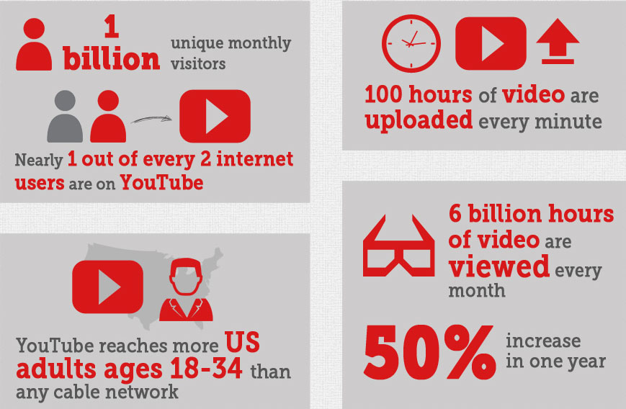I. 80% of YouTube’s traffic is from outside the US.
II. 14% of Americans use YouTube during work hours.
III. YouTube reaches more people than any cable network.
IV. Over 6 Billion YouTube videos are viewed each day.
V. Over 6 Billion hours of videos are watched each month.
VI. 323 days of worth of YouTube Video content is viewed every minute.
VII. 40% of YouTube Videos are watched from the mobile phone.
VIII. One of every two people online are watching a video.

  - Social Media Plan regarding YouTube
    - Regarding YouTube, it would be beneficial to create a YouTube video post every week to either be posted from 9-11am on the weekends or 2-4pm on the weekdays. It does not seem possible at this time to do that task since creating videos is very time consuming and other people at Volute would be far better suited to do this task.
      - A person focusing on YouTube social media would need to devote several hours a week toward creating content and also set aside an additional hour or 2 each day for replying to comments, creating comments, viewing analytics, viewing related videos, and gathering information to generate video ideas.

  - Analytics
3.6.1 YouTube has its own analytics page. 3rd party software and applications aren’t very compatible with YouTube. The YouTube analytics page is viewable at https://www.youtube.com/analytics
    - YouTube’s analytics show watch time, audience retention, demographics, playback locations, traffic sources, devices, subscribers, likes and dislikes, comments and shares
3.6.3 YouTube does not have the ability to connect with applications like Hootsuite so videos must be posted by the user at the specific times specified in 3.5.1.

  - What is the return?
3.7.1 YouTube can generate informational content that can be monetized to generate revenue.
3.7.2 YouTube provides viewers with detailed insight of the company and the product.
3.7.3 YouTube creates videos that can be shared on other social networks, generating additional traffic to and from your page.
3.7.4 YouTube creates a following of viewers, eager to see the newest features of Volute.
3.7.5 YouTube allows for better connecting with users, showing off Volute’s knowledge and experience, finding out what features and apps are selling points are most important to them as consumers.
3.7.6 Create a presence on the number one social video network.

- LinkedIn

4.1 Background
4.1.1 LinkedIn is the most professionally oriented social media network.
4.1.2 LinkedIn is used primarily by businesses and job hunters for either searching for job candidates or searching for job listings.
4.1.3 LinkedIn’s best use for businesses is for hiring and also networking to reach out to potential clients.
4.1.4 LinkedIn is the world’s largest resume pool.
4.1.5 LinkedIn serves as a place to read career oriented blogs and news articles.
4.1.6 LinkedIn is used to provide information about businesses, as well as display their powerful and influential connections.
4.1.7.1 Like Twitter, LinkedIn displays user’s connections publicly, but does so in a more visible way to show which users are connecting.
4.1.8 LinkedIn is similar to Yelp in its ability to endorse user’s skills and also post comments about experience with businesses and clients.
4.1.9 LinkedIn has the ability to create ads to target particular individuals or businesses.
4.1.9.1 LinkedIn allows users to specifically cater ads to as small a niche as seven individuals.

4.2 Audience
4.2.1 LinkedIn is a growing community of business professionals.
4.2.2 LinkedIn is used especially by B2B companies looking for new customers.
4.2.2.1 If businesses find Volute’s profile, they can then can be directed to the Volute website.
4.2.2.2 If Volute is doing business with a LinkedIn connection, that connection can endorse Volute so others will see.
4.2.3 If Volute connects with influential figures or companies, that can help to boost the audience.
4.2.4 Individuals may see Volute’s page and share it and its content with friends and coworkers, potentially leading to indirect business sales.
4.2.5 LinkedIn is most popular with college graduates, higher income households, and employed individuals.

  - Pros and Cons
    - Pros
- LinkedIn’s search engine optimization helps users to be seen by potential clients.
- LinkedIn allows the user to look up specific keywords to find related articles to their field of industry.
- LinkedIn allows a business to present itself in the most professional light on the most business oriented social media platform.
- LinkedIn provides users with comprehensive information about their business.
- Businesses can be endorsed by peers and clients to create creditability which can lead to increased sales.
- LinkedIn allows the user to connect with individuals, as well as businesses
- LinkedIn can easily filter the search to advertise to small niches.
- LinkedIn establishes relationships with potential hires before they’re hiring.
- The user has the ability to join LinkedIn groups that relate their field.
4.3.2 Cons
- There are lots of advertising scams on LinkedIn so it’s challenging to appeal to users without them thinking an ad is fake.
- It’s challenging to create a connection through LinkedIn because both parties must agree to it, however the user may still follow them.
- LinkedIn requires a lot of time to build connections and also start and develop conversations.
- LinkedIn is not the easiest platform to connect with others since communication requires consent from both parties.
- LinkedIn is the oldest social media network being discussed and also has one of the slowest growth rates of any social media network.
- It’s challenging to build up reputation and endorsements since it is not required or recommended through the application.

  - Statistics
 | # Active Users | % of Pop using | % growth rate in last year | % users engaged weekly | Post Frequency | Best Times | Post Lifetime
LinkedIn | 400 Mil  as of Oct 2015 | 25% | 17% | 52% | 1-3 Post per week | 7:30-8:30am  5-6pm | 3 weeks
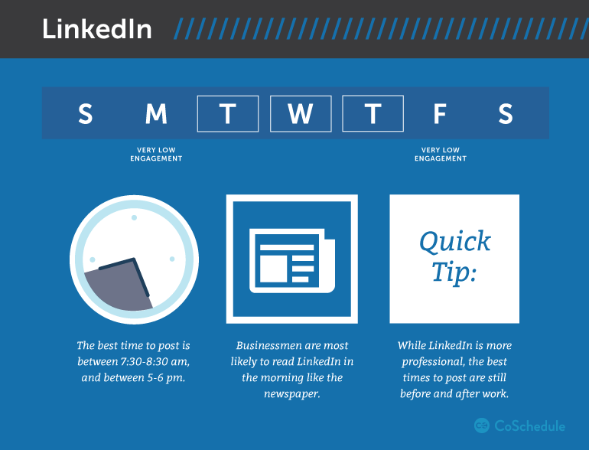

- Every second, 2 new members join LinkedIn.
- 15% of users go to LinkedIn on a daily basis.
- 40% of users have at least a college degree.
- 85% of LinkedIn users are also active on Facebook.
- Over 5.5 Million business owners in the US have a LinkedIn profile.
- 80% of LinkedIn users are from outside the US.
- The average user spends about 17 min a month on LinkedIn.
- The average business CEO’s have 930 connections through LinkedIn.

  - Social Media Plan regarding LinkedIn
- Check for interactions (comments, messages, likes). Strategically choose interactions to respond toward.
- Check LinkedIn analytics through Hootsuite to verify the strategy plan is correct and working effectively.
- Research articles through LinkedIn, like or comment on them.
- Research and develop posts to be input into Hootsuite to be posted at either 8:30-830am or 5-6pm.
- One post shall be done every on Tuesday, Wednesday, Thursday, and Saturday.
- Posts shall either consist of Volute position listings, noteworthy articles, or insightful graphics.
- Research users, add potential connections, try to network, and track competitors.
- Potentially develop ads to target specific individuals or groups.

  - Analytics
    - LinkedIn does not have its own analytics page, however it does allow for 3rd party software and applications to measure it’s analytics.
      - These programs include Simply Measured, Hootsuite, and Buffer.
3.6.1.2 These analytics show the post view numbers, number of views to the profile, replies, new connections, and also the length of time users were on the page

  - What is the return?
4.7.1 Develop a social media presence on the number one B2B social network.
4.7.2 Provide LinkedIn users with detailed insight of the company and the product.
4.7.3 Connect with influential colleges, universities and businesses to build creditability, relations, and clients.
4.7.4 Create a following of viewers, eager to see the newest features of Volute.
4.7.5 Better connect with users, showing off Volute’s knowledge and experience.
4.7.6 Target specific groups or individuals with specific skills that Volute seeks.
4.8.7 Provide users with upcoming events, social happenings, business insight, and noteworthy articles.

5. Google+

5.1 Background
5.1.1 Google+ is a more formal network than Facebook or Twitter, yet slightly less formal than LinkedIn.
5.1.2 Having a Google+ account and actively being logged into it allows the user or business to appear higher on the Google search list for particular associated words.
5.1.2.1 Google+ has the ability to connect easily to Google Docs, Gmail, Gdrive, Google Search, YouTube, and other Google products.
5.1.3 Google+ is comprised of components from several different social networks to work together.
5.1.3.1 Like LinkedIn, Google+ allows users to connect with each other and each party must agree to the request.
1. If the person does not agree to it, the user is only able to follow the public content of the other user.
2. Google+ uses algorithms to show the user content from members not in their associated circles that it feels would be relevant to them, but there is no way to filter or refine it.
5.1.3.2 Like Twitter, Google+ users may use hashtags to become associated with topics outside their circles.
1. Searching a hashtag on Google+ results in also displaying related hashtags to the content searched.
2. Google+ also shows which hashtags in a field are trending the most.
3. Google+ can add hashtags based on content posted using a feature called autohashtags.
5.1.3.3 Like Facebook, there is a newsfeed to show Google+ users recent activity, videos, pictures, and posts, which can either be set to public or private.
5.1.4 Google+ allows the user to create circles where they can categorize what content is viewable by certain groups, and also set content to only be viewed by certain groups.
5.1.4.1 This allows a business to create circles for useful article posters, competitors, as well as target audiences.
5.1.4.2 Google+ circles can also be filtered on how much content the user wants to see from a particular circle.
5.1.5 Google+’s best use for businesses include acting as a company storefront, promoting events, news, sharing articles, and engaging using while building connections.

  - Audience
    - The Google+ demographic is primarily made up of tech savvy males.
5.2.2 Some businesses also have accounts on Google+ which allows those businesses to display more prominently in the Google search engine results.
      - Far less businesses are using Google+, compared to Facebook or Twitter.
    - Many business professionals also use Google Plus
5.2.3.1 Most Google+ users work in the field of engineering, software, and design.
5.2.4 The tone on Google+ is more serious than other social media networks with more individual desiring to to partake in a discussion rather than look at images.

  - Pros and Cons
5.3.1 Pros
- All Google+ accounts are linked to the Google search engine which creates an increased public awareness.
- Google+ allows for multiple business profiles for different components.
- Google search, Gmail, Chrome, YouTube, Gdrive, Google Docs, Google Maps, Google Hangouts and Android can all be easily connected and connected using Google+.
- Google- allows the user to easily sort individuals into different target groups to create posts catered just for them.
- The Google+ audience is more tech savvy so they would be more interested in the Volute platform.
- The Google+ audience is more willing to engage in deep and meaningful conversation than other social media demographics.
- Google Hashtags are superior to other hashtags and allow for related hashtags to show up, as well as autohashtag
- Google+ members can easily search relevant articles to the industry.
- Google+ like LinkedIn, allows its customers to give reviews.
5.3.2 Cons:
- The demographic is somewhat bland, consisting primarily of a male audience in the field of design tech.
- Google+ has far less interaction than other social media networks because it’s challenging to engage the other users.
- Google+ lacks of users when compared to other social media networks.
- When people are logged out of Google+, their search results will change and their company will potentially display further do in Google search results.
- It is difficult to promote a business unless it is done indirectly because of Google+ restrictions.
- Google+ is ineffective at connecting with most businesses directly since many do not use the network.

  - Statistics
 | # Active Users | % of Pop using | % growth rate in last year | % users engaged weekly | Post Frequency | Best Times | Post Lifetime
Google+ | *unknown | 18% | N/A | N/A | 1 post a week | 9-11am | 1 Week
*Google has not reported a number since 2013, which they stated was 540 Million, but they only record the number of accounts on the network. Unlike other social media platforms, Google+ does not record the number of active users. Based on other social media networks, the projected number of active Google+ users are generally somewhere between 100- 250 Million.
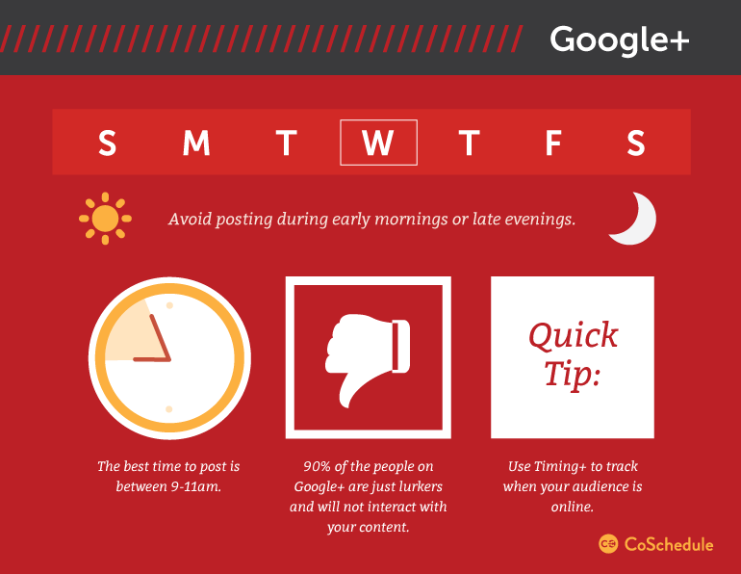

- 77% of Google+ users are Male.
- The average user spends only 7 min on Google+ a month.
- Only 13% of small businesses use Google+.
- 64% of B2B Marketers in North America use Google+.
- The Google+ headline for maximum engagement is 60 characters long or less.
- The average Google+ user is 28 years of age.
- The average CEO on Google+ has 150 followers.
- Only 6% of active profiles post within 18 days, and half of them are YouTube Videos.
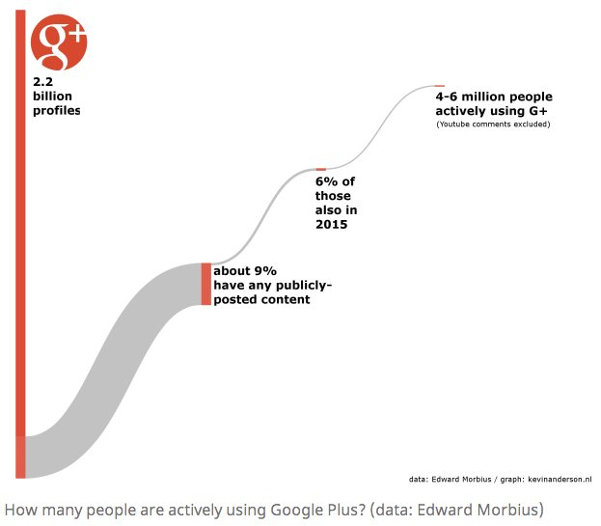

  - Social Media Plan regarding Google+
- Check for interactions (comments, messages, likes). Most likely, there will not be any. Choose important posts to respond toward.
- Check Google+ analytics and also Hootsuite to verify the strategy plan is correct and working effectively.
- Research articles through Google+, comment on some, and choose articles to potentially post to other social outlets.
- Research and develop posts to be input into Hootsuite.
- Posts should primarily either consist of relevant articles or company updates.
- Posts should be once a week on Wednesday.
- Posts should be posted between 9-11am.
- Research users, find out their interests, when they are active, how to appeal to them, what engages them most, track hashtags, and track competitors.

  - Analytics
    - Google+ has its own analytic page which displays total users, new users, post views, Clicks, CTR, and other features.
I. Because Google+ has a questionable user count which seems to be exaggerated in certain ways, I do not advice relying strictly on Google+’s analytics.
5.6.2 Google+ is also compatible with other applications including Hootsuite, Buffer, and others.

5.7 What is the return?
5.7.1 Develop a social presence on the most tech based social media network with many tech oriented people.
5.7.2 Provide users with upcoming events, social happenings, business insight, and noteworthy articles.
5.7.3 Google+ provides less opportunity to directly engage/interact with users than on other networks.
5.7.4 Easily research articles through Google+ and hashtags to use for other social media sites.
5.7.5 Easily access Google maps, and get optimized searching.
5.7.6 The number of active users is less than on other networks, and also there are very few businesses using the platform for networking.

6. Instagram

6.1 Background
6.1.1 Instagram is a photograph and video exclusive social network.
6.1.1.1 Typography done in a photographic way may also be included.
6.1.2 Instagram is one of the fastest growing social networks with one of the highest user engagements.
6.1.2.1 In just 2 years, it’s membership has jumped by 50%, or 200 Million members.
6.1.3 Users have the ability to direct message, reply, and like posts.
6.1.3.1 Instagram also allows users to share their posts on Facebook and Twitter.
6.1.4 Posts are encouraged to use hashtags at a higher rate than other social networks.
6.1.4.1 There is a direct correlation between number of hashtags and user engagement.
6.1.5 The more actively a user posts, the more followers they will earn.
6.1.5.1 But a user must remain active and frequent in their postings to maintain a strong following.
6.1.6 Instagram offers advertising to promote Instagram account pages for businesses, but it’s not cheap and there are not many slots available.
    - Instagram is owned by Facebook, so the two are very compatible with one another.
6.1.8 Instagram is a good platform for finding related hashtags or ideas for content to post.
6.1.9 Instagram’s best use for a business setting is promoting the brand with colorful images.
6.1.10 Instagram is less formal than most social media platforms.

6.2 Audience
6.2.1 Women use Instagram slightly more than men.
6.2.2 Minorities including Blacks and Hispanics use Instagram at a much higher rate than whites.
6.2.3 Over half of Instagram users are under 29.
6.2.4 Common industry fields with Instagram accounts include Hotels, restaurants, design firms, and companies with a lot of photography capability.
6.2.4.1 Any company with graphic, visual artwork, or photography should have a social presence on Instagram.

  - Pros and Cons
    - Pros
- Instagram is great for company branding, creating photographs, and showing insight into a company.
- Instagram is far better at attracting business than Twitter.
- By taking photographs of what makes the company unique, that will create the most engagement on Instagram.
- Photography from conferences, pictures of the team and customers, office perk or gifts, as well as customers and products are what generates the most interaction on the network.
- Instagram photos can be linked to Facebook and Twitter.
- Instagram is better than Pinterest at creating user engagement.
- Instagram has more daily users and activity than most other social media networks.
- Instagram has the second highest engagement rate of any social media network.
- In the last year, Instagram has the highest growth rate of any social media network.
- Because Instagram is primarily used on a mobile device, it can be accessed from anywhere at anytime.
- Instagram is a different type of platform so it doesn’t have the same competition that other social networks face.
6.3.2 Cons:
- Accounts must post at least once ever other week. Otherwise engagement will significantly decline.
- Instagram is a challenging platform to come up with interesting photographs and subject matter to post.
- Links don’t work in captions making it challenging to drive users to other websites or applications.
- There is limited advertising available for businesses.
- Instagram is challenging to integrate with other social media networks since it is such a different type of network.
- Instagram is only really compatible using a mobile device.
- Instagram appeals more to younger viewers.
- As a user, you are judged by quantity of followers and posts rather than quality.
- While using more hashtags will generate a higher user engagement, using too many may irritate other users.
- Instagram is a fairly time consuming social media network.

  - Statistics
 | # Active Users | % of Pop using | % growth rate in last year | % users engaged weekly | Post Frequency | Best Times | Post Lifetime
Instagram | 400 Mill as of Oct 2015 | 28% | 25% | 76% | 1.5 post per Day | 2-3 pm  8-9 pm | 21hrs 36 min
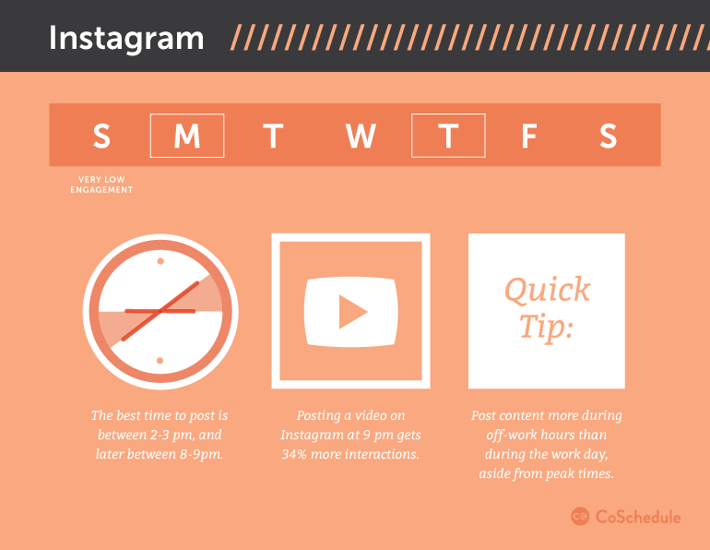
- Instagram interactions are highest with 11+ hashtags but 5-10 is the ideal number to avoid agitating other users.
- 53% of people age 18-29 use Instagram.
- 49% of Instagram users are on the app daily.
- Brand engagement is highest on Instagram out of any social network at 4.21%
- 50% of comments are posted in the first 6 hours of an image being posted.
- @mentions in captions receive 56@ more engagement.
- Adding a Location to an image results in 79% more engagement.
- Only about 25 %of Instagram users are from the US.
- Instagram user numbers are projected to increase by 27% in 2 years.
- Instagram’s per-follower engagement rate for top brands are 58 times higher than on Facebook and 120 times higher than on Twitter.
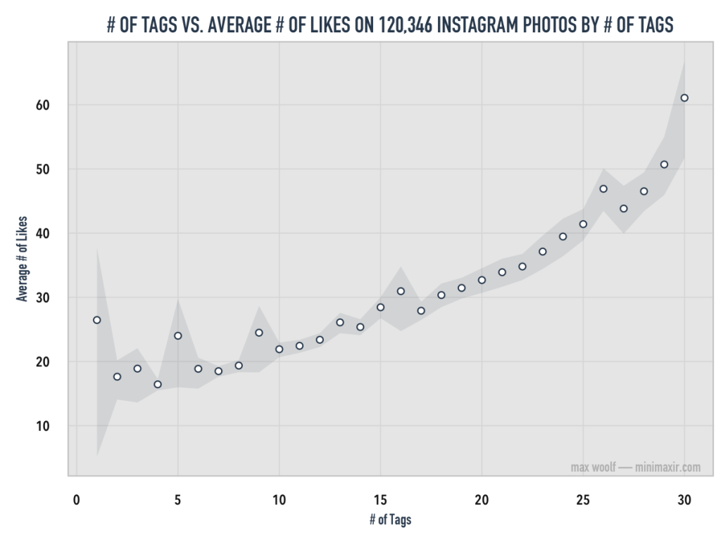

  - Social Media Plan regarding Instagram
- Check for interactions, (comments, direct messages, likes). Strategically choose important ones to like or respond toward.
- Check Instagram analytics through Hootsuite to verify the strategy plan is correct and working effectively.
- Look through other users images to find relevant or inspirational ideas for photograph subject matter.
- Initially post 2-3 times through the work week on Monday, Thursday or Friday, and if more content develops, posts may become more frequent.
- Posts shall take place either at 2-3pm or 8-9pm.
- Posts should primarily consist of company happenings (Office meetings, events, conferences, campuses of universities toured at, etc), inspirational typography, infographics, or photos of the product.
- Research users, find out their interests, when they are active, how to appeal to them, track hashtags, and track competitors.

  - Analytics
    - Instagram is one of the easiest apps of which to track analytics.
6.6.1.1 Analytic applications and software include Minter, Simplymeasured, Unionmetrics, buffer, Hootsuite, Pixlee, Thenextweb, Iconosquare, Spountsocial, Jennstrends, and countless others.
6.6.2 Instagram can track followers/unfollows, interactions, interaction rate by post, interaction rate by hour, number of likes, interaction rate by time, average likes per post, average comments per post, the demographics of the audience, in addition to other information.

6.7 What is the return?
6.7.1 Develop a social presence on the fastest growing social network.
6.7.1.1 Instagram very different from other social media networks, geared more towards visual thinkers.
6.7.2 Instagram provides users with photographic updates of Volute’s happenings.
6.7.3 Instagram successfully engages users on a social media network that has a higher engagement than almost any other network.
6.7.4 Show off the very visual product that is the Volute platform on the most visual network that exists.
6.7.5 Use Instagram images to connect and post content to other social media networks.
6.7.6. Provide users with a different experience that is more personal and visual than they would get with other social networking platforms.

7. Pinterest

7.1 Background
7.1.1 Pinterest is a photograph exclusive social network.
7.1.1.1 Typography done in a photographic way may also be included.
7.1.2 Share links on Pinterest centered around visual themes.
7.1.2.1 Pinterest is great for sharing photography, travel, and industry related images.
7.1.2.2 Pinterest is also great for sharing holiday images.
7.1.3 Pinterest photos are linked back to their original source to drive traffic to and from the Network to other websites.
7.1.4 Pinterest’s best business use would be promoting the business using visual imagery.
7.1.5 Pinterest’s closest competitor in the way of what the platform does is Instagram.
7.1.5.1 Pinterest however only has about ¼ the following of Instagram.
7.1.5.2 Pinterest demographics are also much more female skewed than Instagram.
7.1.6 Pinterest allows users to promote certain pins to target users.
7.1.7 Unlike other social medias, posting original content is not the standard
7.1.7.1 It’s perfectly acceptable to post others content or repin it as it will still drive traffic back to the original location of that image.
7.1.8 Hashtags are commonplace on Pinterest.
7.1.8.1 Hashtags are only clickable in the pin description.
7.1.8.2 Hashtags are most effective when they are unique to the product brand.
7.1.8.3 Hashtags don’t have any purpose on Pinterest.
1. If you search dog, or #dog, the results will be the same.

7.2 Audience
7.2.1 Women make up about 90% of Pinterest users.
7.2.1.1 42% of all US women use Pinterest.
7.2.1.2 13% of all US men use Pinterest.
7.2.2 Over 60% of Pinterest users are under 50 years of age.
7.2.3 Most people using Pinterest are from rural locations.
7.2.4 Most Pinterest users are college graduates with high incomes.
    - 25% of all US adults use Pinterest.
    - Only ¼ of users check Pinterest daily.
    - Most Pinterest users are Caucasian.
    - Pinterest is used heavily by retailers, manufacturers and travel sites. All of whose brands lend themselves to imagery.

  - Pros and Cons
    - Pros
- Can create a following for a Pinboard.
- Pinboards are hyperlinked to the original source which can drive traffic to external sources and does so at a higher rate than Twitter or YouTube.
- It’s easy for other users to share others content to promote both themselves and others.
- Since it is photo based, it’s not time consuming and the amount of content is sometimes overwhelming
- It’s easy to research other people’s content and post it.
- It’s easy to connect with users because posts are public and can be searched based on specific keywords.
- It works as a better platform to drive sales to an external website.
- Pinterest is a great for company branding, creating photographs, and showing insight into a company.

    - Cons
- Pinterest is a competitor of Instagram but is less successful.
- The social network user base is not very large when compared to other social networks.
- The demographic is very one sided with the platform primarily only appealing to female audiences.
- A lot of time must be spent looking up others content, repining and following, as well as generating original content.
- It’s not very easy to share lengthy texts since the network is primarily image based.
- Unless pins are filled with detailed descriptions, they won’t become searchable.
- Pins for business and personal should both exist, but not on the same pinboard.

  - Statistics
 | # Active Users | % of Pop using | % growth rate in last year | % users engaged weekly | Post Frequency | Best Times | Post Lifetime
Pinterest | 100 Mill as of sept 2015 | 25% | 11% | 55% | 5 posts per Day | 8-11pm | Varies
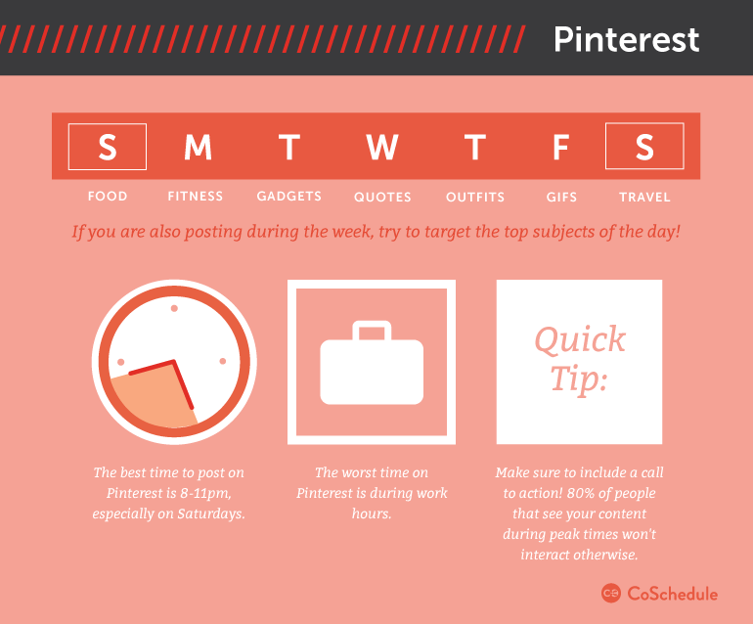
- 45% of Pinterest users are from outside the United States.
- 4.8% of Americans use Pinterest during work hours.
- Growth rate in male monthly Pinterest users in that last year has increased by 120%.
- The average user spends 98 minutes a month on Pinterest.
- The average user spends 14 minutes a week on Pinterest.
- Pinterest users are projected to grow by 22% within the next year.
- 33% of New Pinterest users are men.
- 75% of Pinterest usage takes place on mobile devices.
- 93% of Pinners shopped online in the past 6 months.
- Women use Pinterest more as a wish list and men use it more as a shopping cart.
- Pins with prices get $36% more likes than those without.
- Images without faces receive 23% more repins.
- Promoted pins perform long after campaigns end.
- Pinterest interest engages users twice as much as twitter did at it’s age.
- 80% of pins are repins or things that others have already shared.

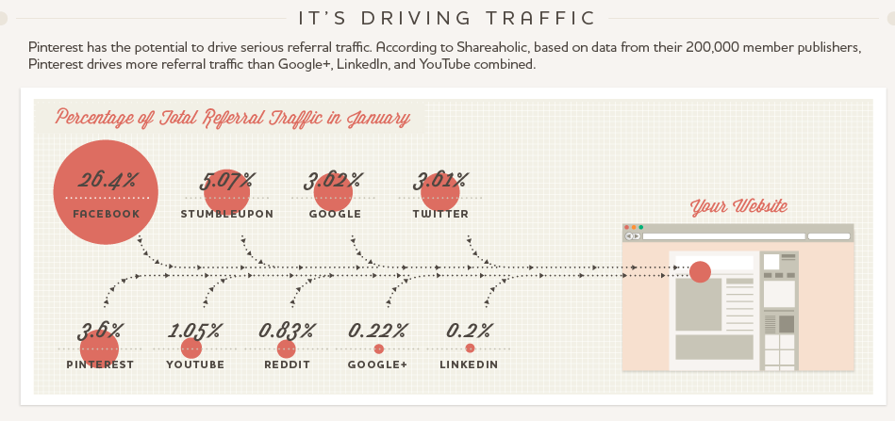

  - Social Media Plan regarding Pinterest
    - Regarding Pinterest, I do not feel it is in Volute’s best interest at this time to try to actively pursue a Pinterest account.
    - If a plan was to take effect, the user would have to post 5-10 pins a day between 8-11 pm.
    - 1 hour would need to be devoted towards Pinterest to search pins, develop content, as well as view Pinterest analytics.

  - Analytics
    - Pinterest is a fairly easy app to track analytics on.
7.6.2 Pinterest has its own analytic software which can be viewed at https://analytics.pinterest.com/ and also https://business.pinterest.com/en/pinterest-analytics
7.6.3 Applications and software such tailwind can assist in posting pins at particular times.
7.6.4 Pinterest can track average daily impressions, average daily views, repins, favorites, and members following your pinboards.

7.7 What is the return?
7.7.1 Develop a social presence on one of the fastest growing socially visual networks.
6.7.1.1 Become a member of a platform very different from other social media networks, geared more towards visual thinkers.
7.7.2 Provide users with photographic updates of Volute’s happenings.
7.7.3 Instagram would provide nearly all Pinterest has with a higher following, and also a higher engagement.
7.7.4 Show off the very visual product that is the Volute platform on one of the most visual networks that exists.
7.7.5. Provide users with a different experience that is more personal and visual than they would get with other social networking platforms.
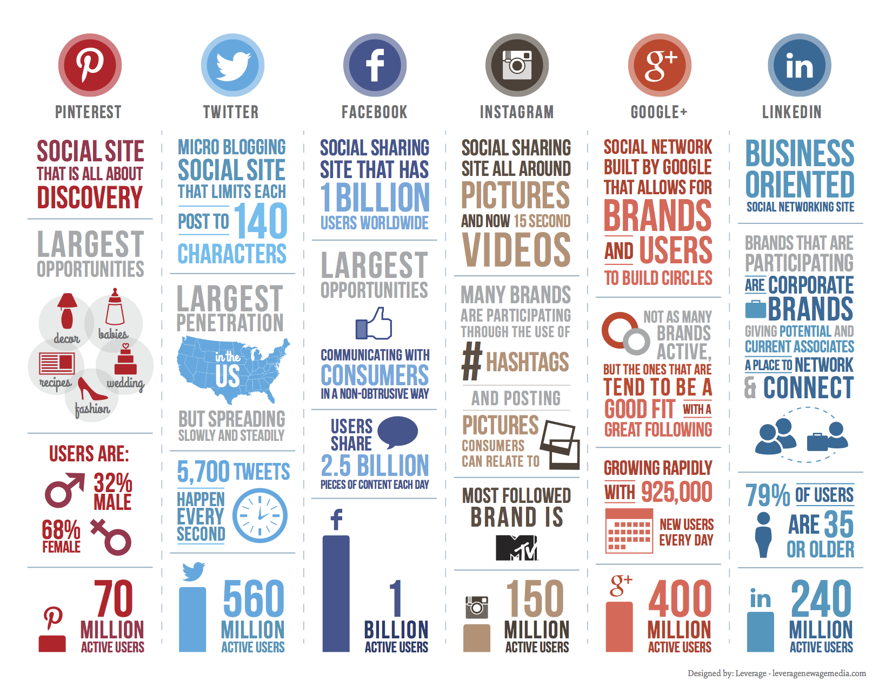

8. Blogging

  - Information
8.1.1 Many websites recommend posting blogs biweekly either about your product, or something relevant to the field.
    - These allow companies intelligence, knowledge of the field, experience, and also provide a personal element. Consumers can put a name to a face.

8.1.3 Blogging helps to drive traffic to the website.
8.1.4 Every post adds an increased potential to attract viewers to the page.
8.1.5 Blogs can be posted on social media which helps generate more traffic to the website and lead to increased sales.
8.1.5.1 It helps convert traffic into leads
8.1.5.2 It helps establish authority
8.1.5.3 It drives long term results

Strategy
Regarding Blogging, Michael said he or Jeff could create a blog post. I would recommend creating one at least once every two weeks. It could be about the product, an interesting article related to the field, or an update of where Volute is and what it has done recently (Colleges meet with, conferences, meetings, etc).

