Facebook Posts

- Monday 1pm
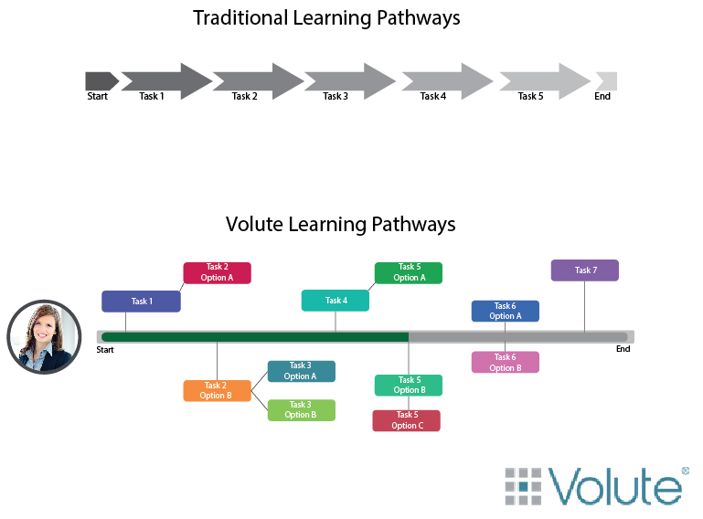
Everyone learns differently. Education should embrace this. Unlike traditional LMS, the Volute platform caters to your unique learning style to build the Learning Pathway that works best for you!
#edtech #adaptivelearning #personalized

- Tuesday 3pm
Interesting article in the #EdTechtimes about social media integration in schools. What do you think about integrating social media into education?
http://edtechtimes.com/2015/11/07/how-can-teachers-use-social-media-in-school/

- Wednesday 1pm.
Wonder what he would have thought of Volute?
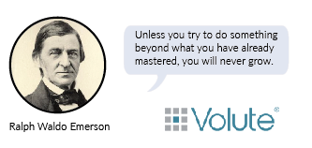

4. Thursday 1pm
Access Volute from your home, or on the go. Using Volute’s mobile application, the user can view submitted assignments, track how long they spend reading digital course material, and conduct polls that provide immediate feedback. #mobility #gamechanger #edtech

- Friday 1pm
“Initial LMS designs have been both course- and instructor-centric, which is consonant with the way higher education viewed teaching and learning through the 1990s.”
– EDUCAUSE, 2015
The entire supporting architecture needs to change to move us from teacher-centric to learner-centric models. But how?
Volute’s answer: Web Components.

Twitter
- Monday 12:30pm
What do you want to see in a learning platform? I think we’ve got it! #Gamechanger #LMS #edtech
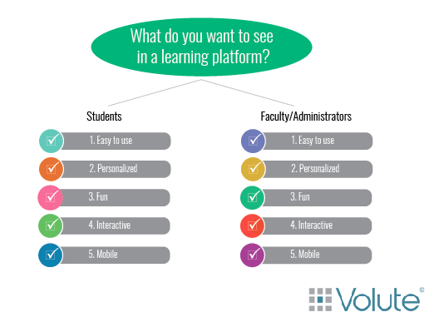
- Tuesday 12:30pm

Everyone learns differently. The Volute platform accounts for this.
#edtech #adaptivelearning #personalized

- Wednesday 12:30pm
Volute. Not Your Average LMS. We think “App”-side the box. #edtech #gamechanger #gamified

4.
Wednesday 5pm
What do you think about gamified learning in schools? #gamification #edtech
http://www.edtechmagazine.com/k12/article/2015/09/gamified-social-studies-takes-fantasy-geopolitics

5.Thursday 9am
Technology is evolving. How can we integrate this into learning? #Edtech #personalizedlearning #LMS

Thursday 12pm
6. Wonder what he would have thought of Volute? #education #edtech #lMS
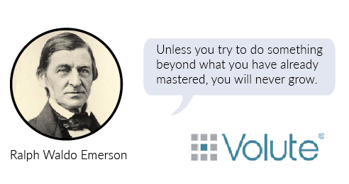

7. Friday 12:30pm
#edtech is changing the field of science! #highered #edu15 http://www.ischoolguide.com/articles/34532/20151118/oeb-conference-berlin-showcase-latest-life-science-education-technology.htm

8. Friday 5:30pm
Access Volute from anywhere! #mobility #edtech #gamechanger

LinkedIn
- The education industry is evolving and becoming more gamified. LMS companies need to keep up. Just look how this classroom turned a history lesson into Fantasy Geopolitics.
http://www.edtechmagazine.com/k12/article/2015/09/gamified-social-studies-takes-fantasy-geopolitics

- “Initial LMS designs have been both course- and instructor-centric, which is consonant with the way higher education viewed teaching and learning through the 1990s.”
– EDUCAUSE, 2015
The entire supporting architecture needs to change to move us from teacher-centric to learner-centric models. But how?
Volute’s answer: Web Components.

At Volute, we know everyone thinks differently. Not everyone is a visual learner. People learn at different paces. Some people struggle to grasp new concepts while other breeze by. The Volute platform allows the user to create their own pathway to learning.

- “The Volute Public marketplace allows sharing and licensing between education institutions and third parties. Universities and colleges specializing in specific areas can license packages of their IP - as Volute Web Apps - to other colleges and universities whose specialty and reputation lies elsewhere.” Michael Croft

- “Teachers can leverage smartphones and tablets in classrooms allowing for more personalized experiences with their students and real-time data analysis. Using mobile applications, teachers can view submitted assignments, track how long students spent reading digital course materials, and conduct polls that provide immediate feedback of who needs extra help.” Michael Croft

Google+
Can duplicate LinkedIn posts, Interesting twitter articles, and most Facebook posts

Instagram
- Monday 2pm
We think “app”-side the box! #Volute #edtech #gamechanger #edapp #personalizedlearning

2.Tuesday 3pm
Learner Centric Learning? We say yes! #Volute #edapp #adaptivelearning #edtech #education

3.Wednesday 8pm
What are you looking for in an LMS? I think we’ve got it! #personalized #adaptivelearning #edtech #volute #gamechanger

- Thursday 2:30 pm
Create your own unique Learning Pathway! #adaptivelearning #machinelearning #edtech #learningpathway #volute

- Friday 2:15pm
The Volute Marketplace! Looks “app”-etizing, right?
#Volute #edtech #virtual Marketplace #edapp #gamechanger

